University of Jordan
Computer Engineering Department
CPE439: Computer Design Lab

Experiment 2: 16-Bit ALU

It is required to construct and test a Verilog module for a 16-bit ALU similar to the 32-bit ALU described in the computer organization course. You should use modular design where you start by building and testing low-level modules using the library modules defined in Lib439.v, then using the low-level modules in larger modules. The symbol and function of this ALU are shown below.
ovf
zero
16  16  16  m (operation)  result  A  B  ALU  3  1  1
  m (operation) | Function
  000 | And
  001 | Or
  010 | Add
  110 | Subtract
  111 | Set on less than

Full Adder
We suggest that you start by building a Verilog module for a full adder that has the following symbol and truth table:

1-bit Full Adder  a  b  sum  CarryIn  CarryOut
  a | b | CarryIn | CarryOut | sum
  0 | 0 | 0 | 0 | 0
  0 | 0 | 1 | 0 | 1
  0 | 1 | 0 | 0 | 1
  0 | 1 | 1 | 1 | 0
  1 | 0 | 0 | 0 | 1
  1 | 0 | 1 | 1 | 0
  1 | 1 | 0 | 1 | 0
  1 | 1 | 1 | 1 | 1

The Verilog module for this adder should be similar to the following code:

module FullAdder(sum, CarryOut, CarryIn, a, b);
output sum, CarryOut;
input CarryIn, a, b;
// implementation details are left to the student
…
endmodule

Multiplexer
Then build and test a 4-to-1 multiplexer module that has Verilog code similar to the following code:

module Mux_4_to_1(Result, s, i0, i1, i2, i3);
output Result;
input [1:0] s;
input i0, i1, i2, i3;
// implementation details are left to the student
…
endmodule

1-Bit ALU
Then use the full adder and multiplexer to build a 1-bit ALU module that has the following diagram.

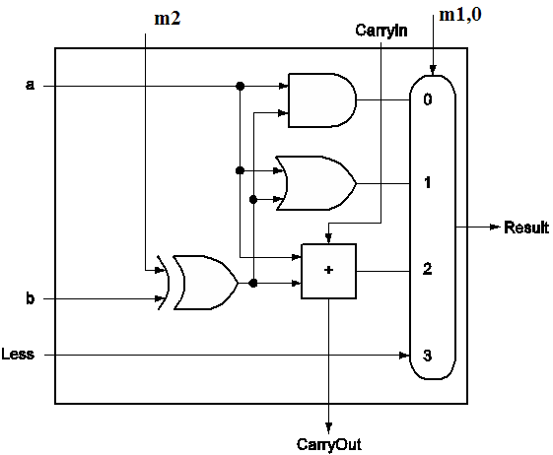

The Verilog module for this circuit should be similar to the following code:

module ALU_1(Result, CarryOut, CarryIn, a, b, Less, m);
output Result, CarryOut;
input CarryIn, a, b, Less;
input [2:0] m;
// implementation details are left to the student
…
endmodule

16-Bit ALU
Finally use 16 modules of the 1-bit ALU module to build the module of the required 16-bit ALU. Note that you need also to add gates to implement the zero and overflow signals.

Report
Your report should include detailed design, Verilog code for all modules including your test modules, and timing diagram that demonstrates the correct operation of your design. Bonus marks will be given to the design that uses carry-look ahead scheme. Also estimate the maximum delay expected for you design.

