0907432 Computer Design (Fall 2007)

Quiz 2B
الاسم: رقم التسجيل: رقم الشعبة:
===========================================================================
Instructions: Time 10 minutes. Closed books and notes. No calculators. Please answer all problems in the space provided. No questions are allowed.

Q. Refer to the figure below from the chapter on limits on ILP. Can we exploit more ILP for benchmark “li” by using renaming registers more than 256? Why?
___No, because the available ILP does not need registers more than 256.__

_________________________________________________________________________

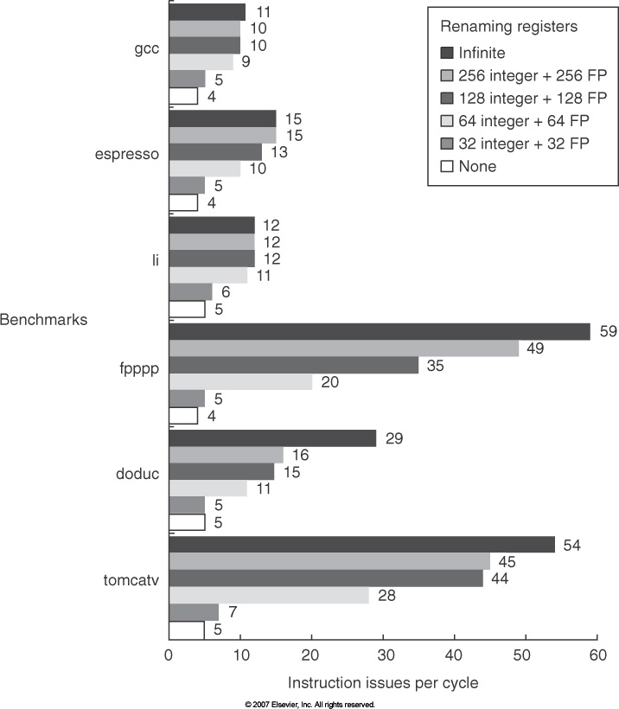
Q. Refer to the figure below from the chapter on limits on ILP. What is “Inspection” memory alias analysis?
___This analysis is done by examining the memory instructions at compile time to _

___determine whether they access same locations._____________________________

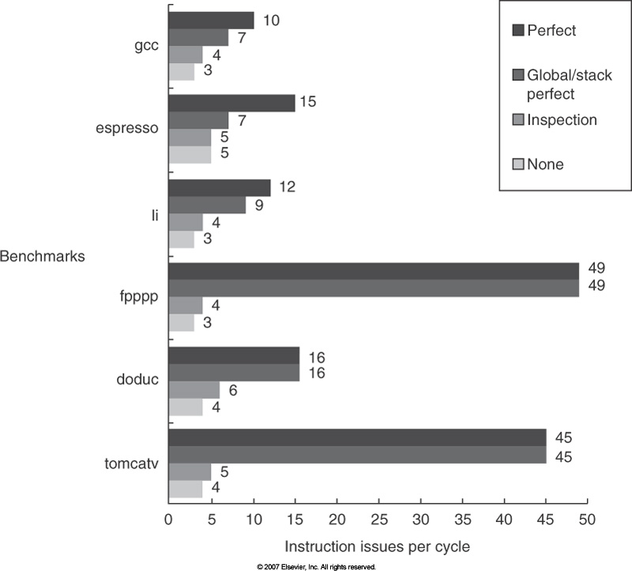
Q. In one experiment, it took longer to run 2 SPEC benchmarks on Pentium 4 with SMT compared with running them serially. Give probable reason.

____Running the 2 benchmarks simultaneously generates more capacity and ___

____conflict cache and TLB misses. ________________________________________

Q. The distributed shared-memory multiprocessor shown in the figure below uses the directory-based cache coherence protocol described in the class. Each cache is direct-mapped, with four blocks each holding two words (least significant word is on the right). Note that the cache tag contains the full address. The cache states are denoted M, S, and I for Modified, Shared, and Invalid. The directory states are denoted DM, DS, and DI for Directory Modified, Directory Shared, and Directory Invalid. The figure shows the initial cache and memory state. What is the resulting state when P15 reads from address 110? Mark any state change on the figure itself. What is the read word? _30____

<Good Luck>

