0907432 Computer Design (Fall 2007)

Quiz 2A
الاسم: رقم التسجيل: رقم الشعبة:
===========================================================================
Instructions: Time 10 minutes. Closed books and notes. No calculators. Please answer all problems in the space provided. No questions are allowed.

Q. Refer to the figure below from the chapter on limits on ILP. Why the IPC of “li” is much smaller than that of “tomcatv”?
___Because “li” has many short dependencies and “tomcatv” has large amount of___

___loop-level parallelism____________________________________________

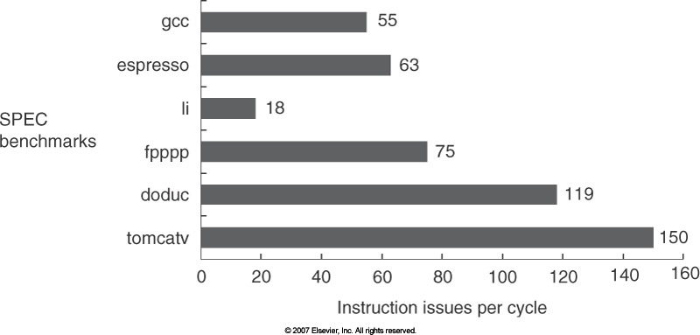
Q. Refer to the figure below from the chapter on limits on ILP. Why does the IPC decrease when moving from “Perfect” branch predictor to “None”?
____Because the amount of parallelism that can be exploited across multiple basic _____

____blocks decreases.____________________________________________________

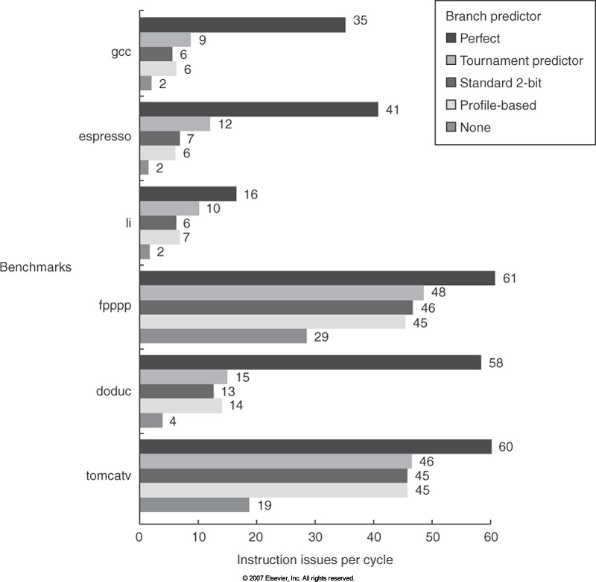
Q. State two changes the IBM designers did to support SMT in Power 5 (with respect to Power 4).
Any two of the following:
- Increased associativity of L1 instruction cache and the instruction address translation buffers
- Added per thread load and store queues
- Increased size of the L2 and L3 caches
- Added separate instruction prefetch and buffering per thread
- Increased the number of virtual registers
- Increased the size of several issue queues

Q. The SMP shown in the figure below uses the write-back invalidate snoopy cache coherence protocol described in the class. Each cache is direct-mapped, with four blocks each holding two words (least significant word is on the right). Note that the cache tag contains the full address. The coherence states are denoted M, S, and I for Modified, Shared, and Invalid. The figure shows the initial cache and memory state. What is the resulting state when P1 writes 48 to address 108? Mark any state change on the figure itself.

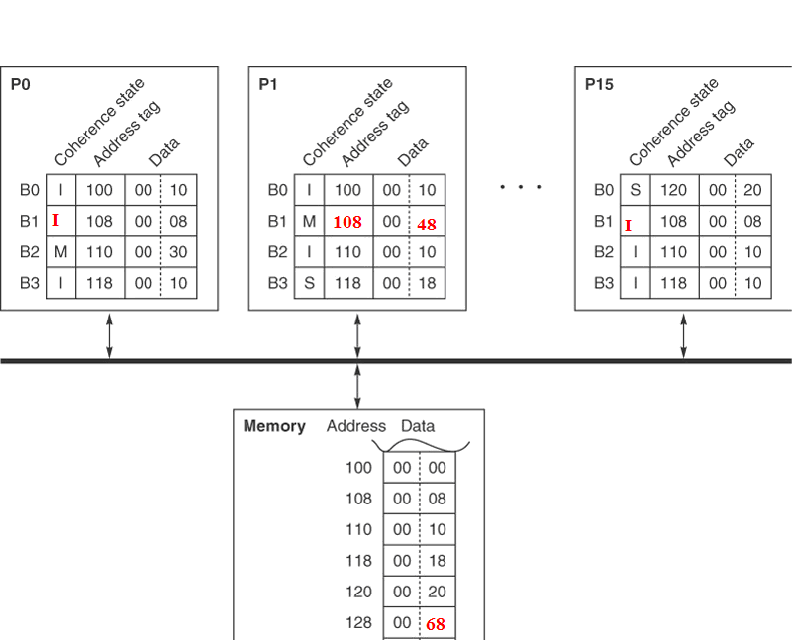

<Good Luck>

