University of Jordan
Computer Engineering Department
CPE431
Performance Evaluation and Modeling

Assignment 3
UART Design

Objective:
The objective of this experiment is to design a system that is capable of transmitting and receiving serial data, and converting it to parallel data for the interface with the system microprocessor.

Experiment:

The design consists of two main modules:
1. Transmitter Module:
This module should be declared as follows:
module TX(Data, register, WR, CS, clk, reset, TXout);
input [7:0] Data;
input register, WR, CS, clk, reset;
output TXout;
………………………
………………………
endmodule

2. Receiver Module:
It should be declared like this:
module RX(Data, WR, RD, RXin, CS, clk, reset, INT, Error);
Inout [7:0] Data;
Input WR, RD, RXin, CS, clk, reset;
Output INT, Error;
…………………………
…………………………
endmodule

Explanation:
The Transmitter module should contain two registers: a data register and a control register. The data should be entered through the Data input pins, and the register to which this data is loaded should be chosen by the ‘register’ input pin as follows:

register = 0 Control register.
register = 1 Data register.
WR and RD are Write and Read signals respectively and CS is chip select.
The reset pin should be used to reset all the inside components of your modules before operation, and the clk input is the clock input to be used in the baud rate generation.
The function of this module is to convert the input parallel data into a serial data, at a specified baud rate. The 8-bit parallel data should be converted to serial and added to the serially transmitted data frame. The frame should also contain a start bit, stop bit and a parity bit.
The transmitted frame should look like this:
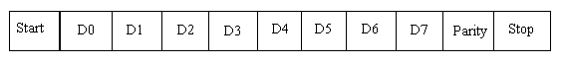
The start bit is always a logic ‘1’; the stop bit is always a logic ‘0’, and parity is even. The data to be transmitted is loaded to the data register, the control register should be used to program the baud rate of the output data; this is done by programming the control register as follows:
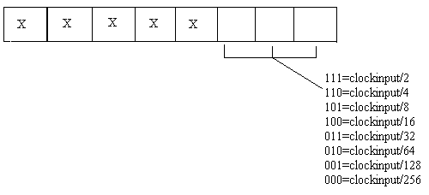
The control register should be programmed first and as soon as data is loaded into the data register, serial transmission should start. The serial data should appear at the TXout pin.

The Receiver module does not have ‘register’ input as data is only written into the control register and read from the data register. Thus, the RD and WR signals are enough. As soon as this device starts receiving data it should start the shifting process. After the shifting process is complete, the INT output should signal that the data is ready to be read. The parity bit should be checked for errors in the transmitted data. If an error is present, a logic high should be placed on the Error pin. The data enters serially through the RXin pin and is read from the parallel 8-bit data pins.

The Test Module:
In this module, first we should program the baud rate for both TX and RX modules, then a data byte should be transferred serially from the TX module and received by the RX module. If the data was correctly recovered then the system works correctly.

To submit:
The student should submit the following:
- A Sketch of the block diagram that shows your design. 2. A Source Code.
3. A log file that shows the results. 4. A timing diagram of the important waveforms.

