0907335 Computer Organization (Spring 2008)

Quiz 2
الاسم: رقم التسجيل: رقم الشعبة: 4
===========================================================================
Instructions: Time 5 minutes. Closed books and notes. No calculators. No questions are allowed.

Q. For the following multi-cycle implementation of MIPS instructions, complete the following table about the values of the control signals.
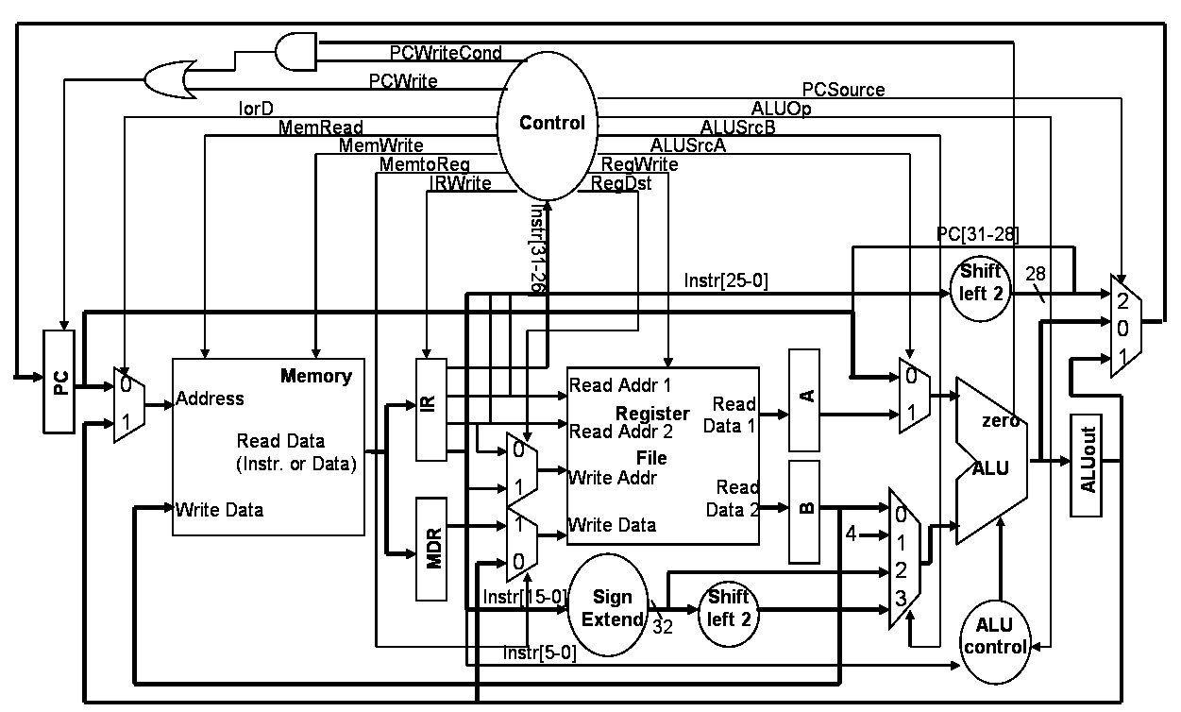

Signal | State | Value
PCWrite | 0: Fetch | 1
ALUSrcB | 0: Fetch | 1
MemWrite | 5: Memory Access of sw instr. | 1
MemtoReg | 7: R-Type Completion | 0
PCSource | 8: Branch Completion | 1

<Good Luck>

