0907335 Computer Organization (Spring 2008)

Quiz 2
الاسم: رقم التسجيل: رقم الشعبة: 4
===========================================================================
Instructions: Time 5 minutes. Closed books and notes. No calculators. No questions are allowed.

Q. For the following multi-cycle implementation of MIPS instructions, complete the following table about the values of the control signals.
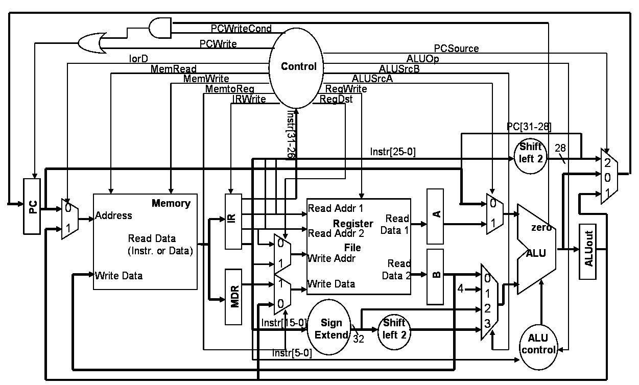

Signal | State | Value
PCWrite | 0: Fetch | 1
ALUSrcA | 1: Decode | 0
RegWrite | 3: Memory Access of lw instr. | 0
MemtoReg | 4: Write Back of lw instr. | 1
PCSource | 9: Jump Completion | 2

<Good Luck>

