0907335 Computer Organization (Spring 2008)

Midterm Exam

===========================================================================
Instructions: Time 90 minutes. Closed books and notes. No calculators or mobile phones. No questions are allowed. Complete and sign the pledge below before you start answering the questions of this exam. Show your work clearly and write your final answer in the underlined space.

عهد والتزام
أنا الطالب:.......................................... رقمي الجامعي:........................ رقم شعبتي:...............

أقسم بالله العظيم أنني سألتزم الصدق والأمانة أثناء أدائي لامتحان نصف الفصل لمادة تنظيم الحاسوب، وأنني لن أغش أو أحاول الغش، ولن أقدم المساعدة لأي شخص أو أتلقاها من أي شخص، طيلة فترة الامتحان. وأن إجابتي على كامل الأسئلة ستكون نتاج جهدي الشخصي وحدي. وأنني أتعهد بتحمل كافة المسؤوليات والعقوبات القانونية، المنصوص عليها في أنظمة وتعليمات الجامعة، في حال عدم التزامي بذلك.

التاريخ: توقيع الطالب:

Q1. A) Complete drawing the below MIPS instruction format showing the name and width of each field.
<2.5 points>
<6> <5> <5> <5> <5> <6>
R-Format: | Op | Rs | Rt | Rd | shamount | funct

B) Without using the multiply instruction, write the minimal sequence of MIPS instructions that multiplies by 5 the content of register $t1 and puts the result in register $t2. Please put proper comments on your code.
<2.5 points>

----- sll $t2, $t1, 2 # t2 = 4 * t1 ---------

----- add $t2, $t2, $t1 # t2 = t2 + t1 --------

Q2. Write a procedure, StrCpy, in MIPS assembly language. The procedure should take two pointer arguments. The first pointer (in register $a0) points to a source null-terminated string and the second pointer (in register $a1) points to a destination string. The StrCpy procedure should copy all the characters of the source string to the destination string.
<5 points>
StrCpy:
lbu $t0, 0($a0) # load one character
sb $t0, 0($a1) # store one character
addi $a0, $a0, 1 # point to next char
addi $a1, $a1, 1 # point to next char
bne $t0, $zero, StrCpy # repeat if not null yet
jr $ra

Q3. For the following C statements, what is the corresponding MIPS assembly code? Assume that the compiler associates Variable x with Register $s1.
<5 points>
if (x == 0)
x = 4;
else
x = -x;

bne $s1, $zero, Skip
addi $s1, $zero, 4
j Out
Skip: sub $s1, $zero, $s1
Out:

Q4. For the following functions,
Function | Bnegate | Operation
and | 0 | 00
or | 0 | 01
add | 0 | 10
sub | 1 | 10
slt | 1 | 11
Design the MIPS 1-bit ALU slice for the least significant bits.
<5 points>
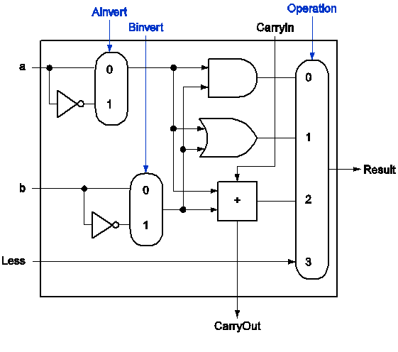
Q5. The binary contents of the FP registers $f0 and $f1 (in IEEE 754 FP single-precision representation) are:
$f0 = 0 10000000 10000000000000000000000
$f1 = 0 10000010 10100000000000000000000

What is the content of $f2?

A) After executing “add.s $f2, $f1, $f0” (single-precision addition)
<2.5 points>
$f0 = + 1.1 * 2¹²⁸⁻¹²⁷ = 1.1 * 2¹ = 11 = 3₁₀
$f1 = + 1.101 * 2¹³⁰⁻¹²⁷ = 1.1 * 2³ = 1101 = 13₁₀

3+13 = 16 = 10000₂ = + 1.0 * 2⁴⁺¹²⁷ = + 1.0 * 2¹³¹

$f2 = __0 1000 0011 000 0000 0000 0000 0000 0000_________

B) After executing “mul.s $f2, $f1, $f0” (single precision multiply)
<2.5 points>
3*13 = 39 = 100111₂ = + 1.00111 * 2⁵⁺¹²⁷ = + 1.00111 * 2¹³²

$f2 = ____0 1000 0100 001 1100 0000 0000 0000 0000______________

Q6. A) Note the following information about a program execution on two computers (Computer 1 and Computer 2). The two computers have different ISAs.
<2.5 points>
 | Computer 1 | Computer 2
IC | 2.0×10⁹ | 2.5×10⁹
CR | 1 GHz | 2 GHz
CPI | 2 | 4

In percents, Computer 1 is faster than Computer 2 by ____25___ %

Time₁ = IC * CPI / CR = 2.0*10⁹ * 2 / 1*10⁹ = 4.0 sec

Time₂ = IC * CPI / CR = 2.5*10⁹ * 4 / 2*10⁹ = 5.0 sec

Speedup = Time₂ / Time₁ = 5 / 4 = 1.25
(1.25 – 1) * 100% = 25%

B) Suppose one machine, A, executes a program with an average CPI of 1.8. Suppose another machine, B (with the same instruction set and an enhanced compiler), executes the same program with 20% less instructions and with a CPI of 1.2 at 800MHz. In order for the two machines to have the same performance, what does the clock rate of the first machine need to be?
<2.5 points>
IC_{A} * CPI_{A} / CR_{A} = IC_{B} * CPI_{B} / CR_{B}

IC_{A} * 1.8 / CR_{A} = (1-0.2) * IC_{A} * 1.2 / (800 MHz)

CR_{A} = 800 MHz * 1.8 / (0.8 * 1.2) = 1.5 GHz

The clock rate of Machine A is ____1.5____ GHz

<Good Luck>

