Homework #2 Solution

Computer Organization

Q1. What are the maximum and minimum integers for 32-bit signed numbers?

A1. Maxint: 0111 1111 1111 1111 1111 1111 1111 1111₂ = + 2,147,483,647_{ten}
Minint: 1000 0000 0000 0000 0000 0000 0000 0000₂ = – 2,147,483,648_{ten}

Q2. For the following functions,

Function | Bnegate | Operation
and | 0 | 00
or | 0 | 01
add | 0 | 10
sub | 1 | 10
slt | 1 | 11

Design the MIPS 1-bit ALU slice for the least significant bits.

A2.

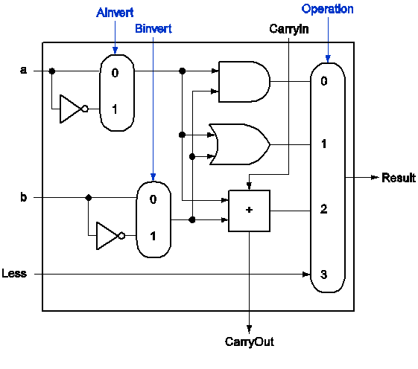

Q3. Design optimized iterative multiplication hardware for multiplying two 32-bit integers.

A3.

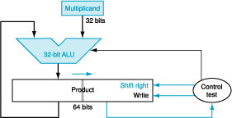

Q4. Now for division, design the division hardware for dividing two 32-bit integers.

A4.

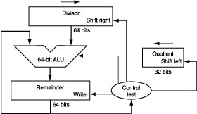

Question 5:
Represent the following in single-precision IEEE floating point. Give your answers in hexadecimal:
a) 2007.0
b) -4014.0
c) -0.00390625 (Hint: -2⁻⁸)
d) 16777215.0 (Hint: 2²⁴ -1)
e) 16777216.0 (Hint: 2²⁴)

Solution:
- 2007 = 11111010111₂ = 1.1111010111₂ × 2¹⁰
Sign = 0
Exponent = 10
E = 10 + 127 = 137 = 1000 1001₂
Significand = 111 1010 1110 0000 0000 0000₂
S | E | F
0 | 100 0100 1 | 111 1010 1110 0000 0000 0000

0x44FAE000

S | E | F
1 | 100 0101 0 | 111 1010 1110 0000 0000 0000
0xC57AE000
S | E | F
1 | 011 1011 1 | 000 0000 0000 0000 0000 0000

0xBB800000

S | E | F
0 | 100 1011 0 | 111 1111 1111 1111 1111 1111
0x4B7FFFFF

S | E | F
0 | 100 1011 1 | 000 0000 0000 0000 0000 0000
0x4B800000

Question 6:

Convert the following single-precision floating point numbers (given in hexadecimal) to decimal:
- 0x3e800000
- 0xbec00000
- 0x46800000
- 0xc67ffc00
- 0x46800200

Solution:

a)
S | E | F
0 | 011 1110 1 | 000 0000 0000 0000 0000 0000
Sign = 0
E = 0111 1101₂ = 125
Exponent = 125 - 127 = -2
Significand = 000 0000 0000 0000 0000 0000₂
1.0 × 2⁻² = 0.01₂
= 0.25

b)
S | E | F
1 | 011 1110 1 | 100 0000 0000 0000 0000 0000
0:011₂ = 0.375

c)
S | E | F
0 | 100 0110 1 | 000 0000 0000 0000 0000 0000
1.0₂ × 2¹⁴ = 100 0000 0000 0000₂ = 16384

d)

S | E | F
1 | 100 0110 0 | 111 1111 1111 1100 0000 0000

-1.111 1111 1111₂ × 2¹³ = -11 1111 1111 1100 = -16380
e)
S | E | F
0 | 100 0110 1 | 000 0000 0000 0010 0000 0000

- 0000 0000 0001₂ × 2¹⁴ = 100 0000 0000 0001 = 16385

Question 7:

Given the following two single-precision IEEE floating-point numbers:
x = 0x3c800000 and y = 0x48800000
Compute the following showing all work: (ignore guard, round and sticky bits)
a) x + y
b) x × y
c) x – y
x:
S | E | F
0 | 011 1100 1 | 000 0000 0000 0000 0000 0000

1.0₂ × 2⁻⁶ = 0.00 0001₂ = 0.015625

y:
S | E | F
0 | 100 1000 1 | 000 0000 0000 0000 0000 0000

1.0₂ × 2¹⁸ = 100 0000 0000 0000 0000₂ = 262144

a) x + y
Denormalize and add:
x = 0.000 0000 0000 0000 0000 0000 1₂ × 2¹⁸
(the 1 is too small to be represented!)
= 0.000 0000 0000 0000 0000 0000₂ × 2¹⁸
y = 1.000 0000 0000 0000 0000 0000₂ × 2¹⁸
x + y = 1.000 0000 0000 0000 0000 0000₂ × 2¹⁸
Result is still normalized, so the final number is:
x + y = 1.000 0000 0000 0000 0000 0000₂ × 2¹⁸
= y
Note: Single-precision representation here does not have the accuracy to represent the operation x + y.

b) x × y
Add exponents:
E = 121 + 145 - 127
= 139
Multiply significands:
F = 1.0 × 1.0
= 1.0
Final number:
S | E | F
0 | 100 0101 1 | 000 0000 0000 0000 0000 0000

1.0₂ × 2¹² = 1 0000 0000 0000₂ = 4096

c) x - y
Denormalize and subtract:
x = 0.000 0000 0000 0000 0000 0000 1₂ × 2¹⁸
(the 1 is too small to be represented!)
= 0.000 0000 0000 0000 0000 0000₂ × 2¹⁸
y = 1.000 0000 0000 0000 0000 0000₂ × 2¹⁸
x - y = -1.000 0000 0000 0000 0000 0000₂ × 2¹⁸
Result is still normalized, so the final number is:
x - y = -1.000 0000 0000 0000 0000 0000₂ × 2¹⁸
= -y
Similar to part a), single-precision cannot accurately represent x - y.

Question 8:
Calculate the relative speeds of a 32-bit adder using ripple carry only, ripple carry of eight 4-bit groups that use carry lookahead, ripple carry of two 16-bit groups that use carry lookahead, and the three-level carry-lookahead scheme. Assume that every gate delay is T seconds.

Solution:

Ripple carry:
32 * 2T = 64 T
Ripple carry of 4-bit groups with CLA:
1T + 2T * 8 + 1T = 18T
Ripple carry of 16-bit groups with CLA:
1T + 2T + 2T * 2 + 2T + 1T = 10T
CLA:
1T + 2T + 2T + 2T + 2T + 2T + 1T = 12T

Question 8:
Design a 4-bit barrel shifter that has the following control signals:

sa0, sa1 | Shift amount
A | 0 perform logical shift  1 perform arithmetic shift
L | 0 right shift  1 left shift

Solution
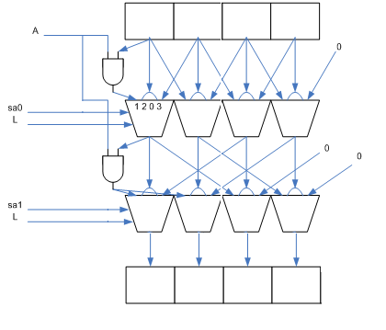
Question 9:

Given the following two implementations P1 and P2 of the same ISA,

Class | CPI on P1 |  |  | CPI on P2 | Instr. Count
A | 1 |  |  | 2 | 1000
B | 2 |  |  | 2 | 2000
C | 3 |  |  | 2 | 1000
D | 4 |  |  | 4 | 3000
E | 3 |  |  | 4 | 2000
 |  | P1 Clock Rate | P2 Clock Rate
 |  | 4 GHz | 6 GHz

- What is the average CPI for P1?
- What is the average CPI for P2?
- What is the CPU execution time for a program that has the instruction counts shown in the above table on P1?
- What is the CPU execution time for a program that has the instruction counts shown in the above table on P2?
- Which processor is faster and by what percentage?

Solution:

Class | CPI on P1 | CPI on P2 | Instr. Count | P1 CPI*IC | P2 CPI*IC
A | 1 | 2 | 1000 | 1000 | 2000
B | 2 | 2 | 2000 | 4000 | 4000
C | 3 | 2 | 1000 | 3000 | 2000
D | 4 | 4 | 3000 | 12000 | 12000
E | 3 | 4 | 2000 | 6000 | 8000
 | Total |  | 9000 | 26000 | 28000
 | Average CPI |  |  | 2.888889 | 3.111111
Freq | 4000000000 | 6000000000
CPU Time | 0.0000065 | 4.67E-06
P2 is faster by | 39.3%

