Instructions:
- This exam booklet has 6 pages and 6 problems.
- The exam is closed book and notes.
- Calculators are not permitted.
- You must show your work.
- No one is allowed to leave the exam room before 5:40 pm.

Student Name: ____________________________________
(الاسم باللغة العربية)

Registration No: ____________________________________

Instructor Name: ____________________________________

Section No or Time: ____________________________________

Problem | Max Points | Score
1 | 6
2 | 3
3 | 4
4 | 6
5 | 6
6 | 5
Total | 30

Good Luck!

Problem 1 (6 points)
Perform the following conversions. Show the details of your solution in the space below.

- Decimal 153 to octal is _________231____________

153 / 2 = 76 rem 1
76 / 2 = 38 0
38 / 2 = 19 0
19 / 2 = 9 1
9 / 2 = 4 1
4 / 2 = 2 0
2 / 2 = 1 0
1 / 2 = 0 1

153 in binary is 010 011 001
In octal 2 3 1

- Decimal 0.6875 to binary is ______________0.1011___________________

0.6875 * 2 = 1.375
0.357 * 2 = 0.75
0.75 * 2 = 1.5
0.5 * 2 = 1.0

- Octal 0.513 to Hexadecimal is ___________0.A58______________

Converting from octal to binary 0.101 001 011
Collect four digits and add padding 0’s 0.1010 0101 1000
Convert from binary to hexadecimal 0.A 5 8

- Hexadecimal 306.D to binary is ____0011 0000 0110.1101______________

Convert every hexadecimal digit to four binary digits
3 0 6 .D
0011 0000 0110.1101

Problem 2 (3 points)
Without converting to binary or decimal, add the two packed BCD numbers 0011 1001 and 0010 0001. Show the details of your solution.

11 1
0011 1001 this is 39
0010 0001 this is 21
-----------
1 1010 larger than nine, so we add 0110
0110
-------------
0110 0000 this is 60

Problem 3 (4 points)
Using NAND gates only, implement the function F = A(CD + B’)

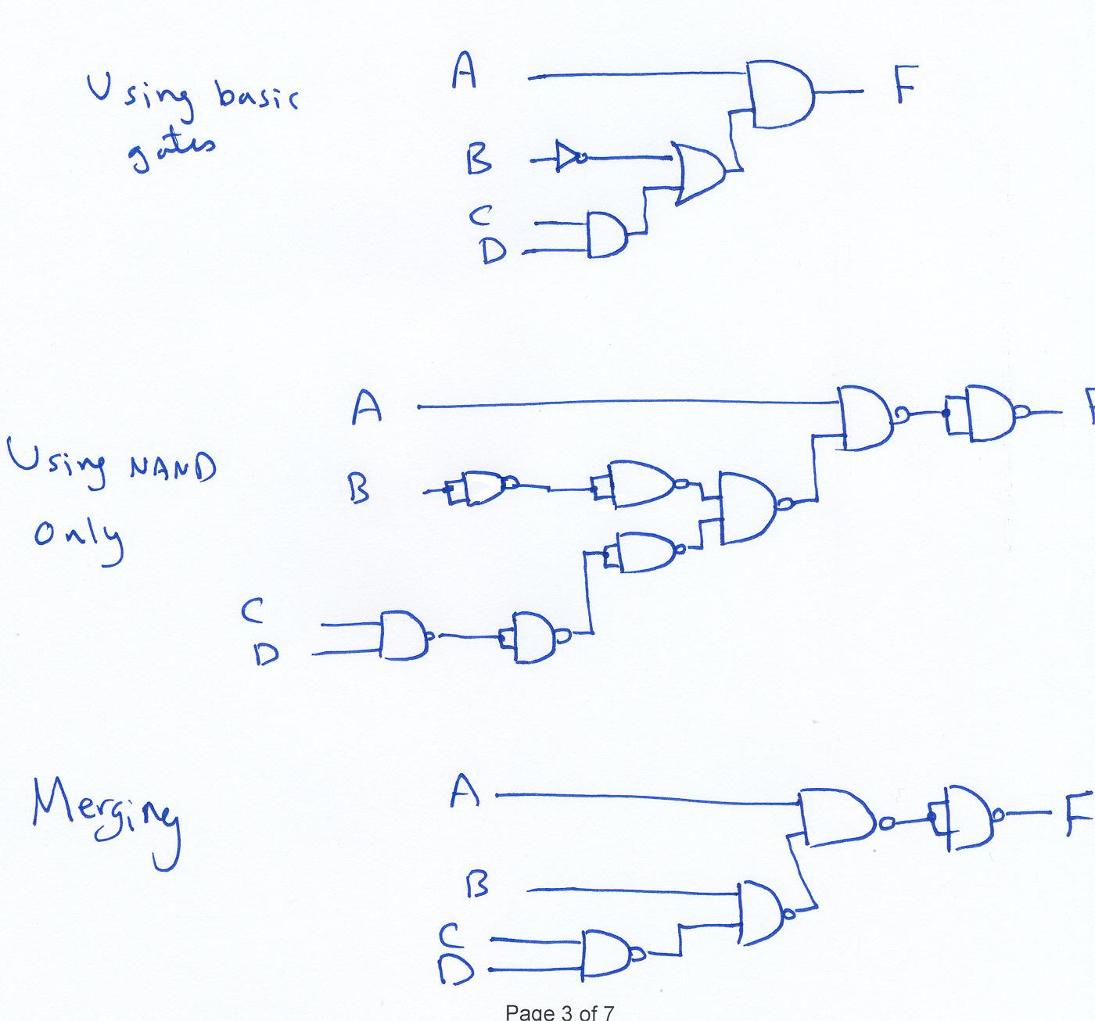
Problem 4 (6 points)
Consider the Boolean function: F = X Y + X' Z
X | Y | Z | F
0 | 0 | 0 | 0
0 | 0 | 1 | 1
0 | 1 | 0 | 0
0 | 1 | 1 | 1
1 | 0 | 0 | 0
1 | 0 | 1 | 0
1 | 1 | 0 | 1
1 | 1 | 1 | 1
- Write the truth table for F in the table shown to the right.

- Find the complement of F in simplified POS form.

F’ = (XY + X’Z)’
F’ = (X’ + Y’) · (X + Z’)

- Express F as a sum of minterms.

F = X’Y’Z + X’YZ + XYZ’ + XYZ

- Implement the Boolean function (F = X Y + X' Z) using basic logic gates.

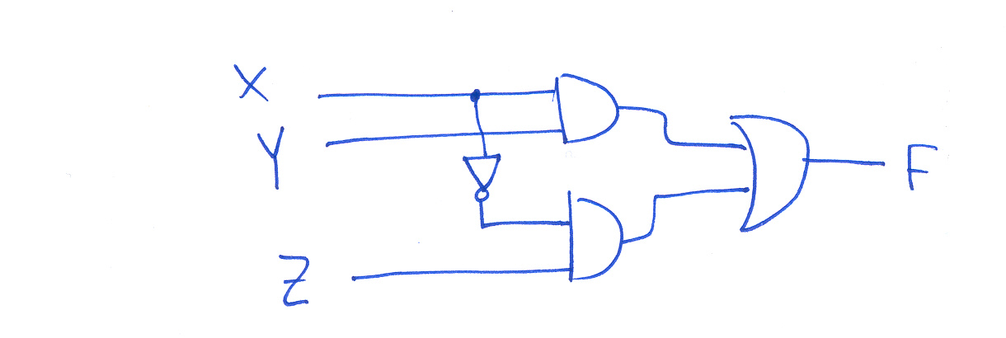

Problem 5 (6 points)

- For the following sum of minterms expression, derive a simplified sum of products (SOP) expression using a Karnaugh map. Furthermore, in the table on the right, identify ALL the prime implicants, indicating which are essential.

F (A,B,C,D)= ∑m (2,5,7,8,9,10,12,13,14,15)

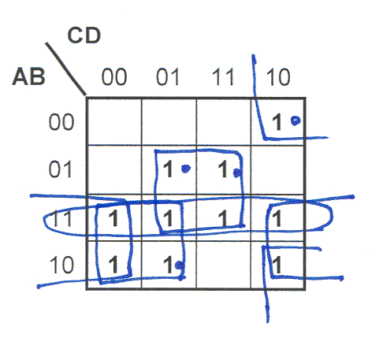 | prime implicants | Essential?
 | prime implicants | yes | no
 | B’CD’
 | BD
 | AC’
 | AB
 | AD’

Simplified SOP Expression: B’CD’+BD+AC’+AB or B’CD’+BD+AC’+AD’

- Obtain a simplified SOP expression for the following K-map:
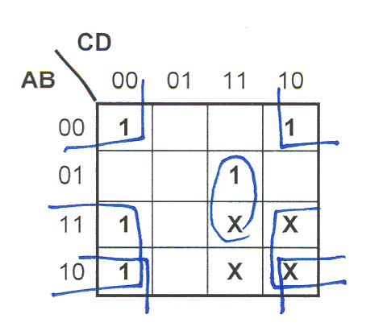

Simplified SOP Expression: _____B’D’+AD’+BCD_____________________

Problem 6 (5 points)
Design a combinational circuit that outputs 1 if its 4-bit input number is divisible by (4)₁₀ and outputs 0 otherwise.

Truth Table: Optimization (K-map):

A | B | C | D | F
0 | 0 | 0 | 0 | 1
0 | 0 | 0 | 1 | 0
0 | 0 | 1 | 0 | 0
0 | 0 | 1 | 1 | 0
0 | 1 | 0 | 0 | 1
0 | 1 | 0 | 1 | 0
0 | 1 | 1 | 0 | 0
0 | 1 | 1 | 1 | 0
1 | 0 | 0 | 0 | 1
1 | 0 | 0 | 1 | 0 |  |  | 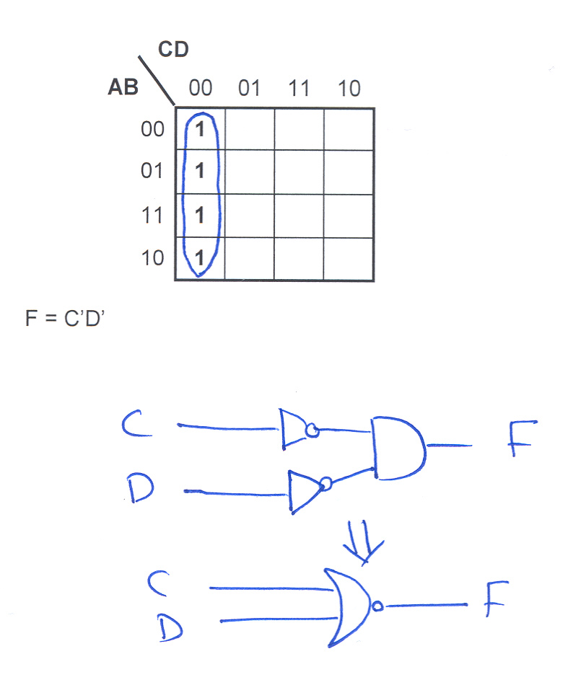
1 | 0 | 1 | 0 | 0
1 | 0 | 1 | 1 | 0
1 | 1 | 0 | 0 | 1
1 | 1 | 0 | 1 | 0
1 | 1 | 1 | 0 | 0
1 | 1 | 1 | 1 | 0

Logic Diagram Using NOR Gates Only:

