Homework 3 Solution
Two marks for each problem

Problem 1
The logic diagram for a 74HC138 MSI CMOS integrated circuit is given in Figure 3-33 in your textbook. Find the Boolean function for each of the outputs. Describe the circuit function carefully.

Y₀ = (A’ • B’ • C’ • (G₁ • G₂A • G₂B))’
Y₁ = (A • B’ • C’ • (G₁ • G₂A • G₂B))’
Y₂ = (A’ • B • C’ • (G₁ • G₂A • G₂B))’
Y₃ = (A • B • C’ • (G₁ • G₂A • G₂B))’
Y₄ = (A’ • B’ • C • (G₁ • G₂A • G₂B))’
Y₅ = (A • B’ • C • (G₁ • G₂A • G₂B))’
Y₆ = (A’ • B • C • (G₁ • G₂A • G₂B))’
Y₇ = (A • B • C • (G₁ • G₂A • G₂B))’

This is a 3-to-8 decoder. The output signals Y_{i} are active low signals. The ith output will be active based on the binary number i present on the input lines CBA. This decoder has three enable signals. It will be enabled when G₁=1, G₂A’=0, and G₂B’=0.

Problem 2
Design a 4-to-16 decoder with enable using five 2-to-4 decoders with enable as shown in Figure 3-21 in your textbook.

Problem 3
A combinational circuit is defined by the following Boolean functions:
F1 = x'yz' + xz
F2 = xy'z' + x'y.
Design this circuit using a decoder and other needed external gates.

F1 = x'yz' + xz = x'yz' + xy’z + xyz
F2 = xy'z' + x'y = xy'z' + x'yz’ + x’yz

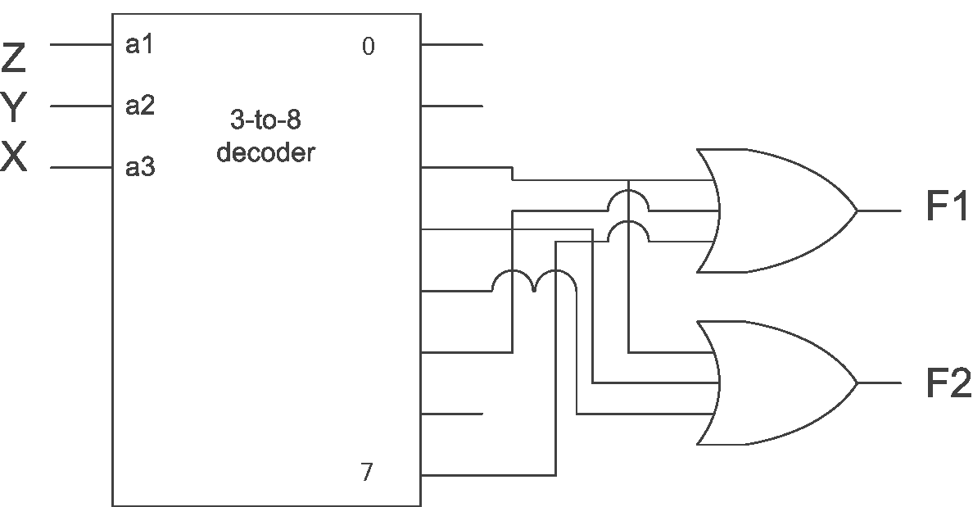

Problem 4
An 8-to-3 priority encoder is designed to have the following input priority order (highest to lowest)): I6, I4, I2, I0, I1, I3, I5, I7. For each row in the table below, enter the encoder output (D2, D1, D0) that will be generated for these two rows of input values.

I0 | I1 | I2 | I3 | I4 | I5 | I6 | I7 | D2 | D1 | D0
1 | 0 | 1 | 1 | 0 | 1 | 0 | 1 | 0 | 1 | 0
0 | 1 | 0 | 0 | 0 | 1 | 0 | 1 | 0 | 0 | 1

Problem 5
Construct a 16x1 multiplexer using two 8x1 and one 2x1 multiplexers. Draw block diagrams only.

Problem 6
A number (X) has the 7-bit binary value 0101100. In the table below, give the 8-bit representation for positive and negative values of X using the representations specified.

+X in sign-magnitude | 00101100
- X in sign-magnitude | 10101100
+X in 1's complement | 00101100
- X in 1's complement | 11010011
+X in 2's complement | 00101100
- X in 2's complement | 11010100

Problem 7
Fill in the table below with 8-bit binary numbers in the given representations. Convert the decimal numbers to the proper representations, and give the correct result in each representation. If the calculation produces an overflow in any of the representations used, note it as "OVERFLOW" and omit the answer.

Note: the first row is an example. Do the rest calculations in the same way and show any required correction.

Problem | Unsigned | 2's Complement
12  + 5 | 0 0 0 0 1 1 0 0  + 0 0 0 0 0 1 0 1  0 0 0 1 0 0 0 1 | 0 0 0 0 1 1 0 0  + 0 0 0 0 0 1 0 1  0 0 0 1 0 0 0 1
60  + 85 | 00111100  + 01010101  10010001 | 00111100  + 01010101  OVERFLOW
(-85)  + 60 | 11010101  + 00111100  - 00011001 | 10101011  + 00111100  11100111

Problem 8
Using a subtractor, design a combinational circuit that compares two 4-bit unsigned numbers A and B to see whether B is greater than A. The circuit has one output X, so that X = 1 if A < B and X = 0 if A ≥ B.

We use a subtractor to subtract A-B. X is connected to the msb of the subtractor’s output. If A is less than B, then the subtraction result will be negative and the msb is 1.

Problem 9
Solve Problem 5-4 of your textbook.

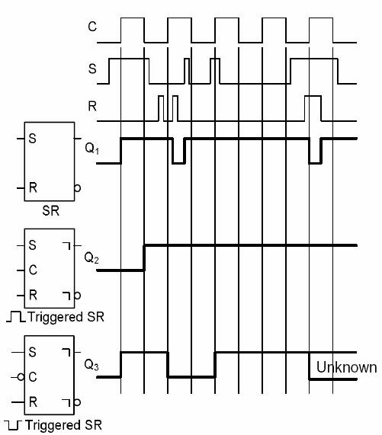

Problem 10
Solve Problem 5-5 of your textbook.

