0907231 Digital Logic (Fall 2008)

Quiz 2A
الاسم: رقم التسجيل: رقم الشعبة:
===========================================================================
Instructions: Time 5 minutes. Closed books and notes. No calculators. No questions are allowed.

Q. On the following logic diagram and for each input signal, specify the input values needed (0 or 1) such that Y6’ is 0.

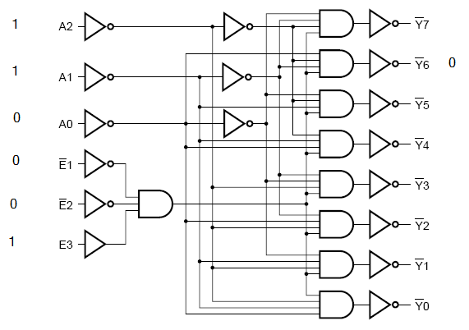

<Good Luck>

